**Q1. Create and compress the file with bzip2**

Ans. Touch filename

Bzip2 filename

Or

Bzip2 –z filename

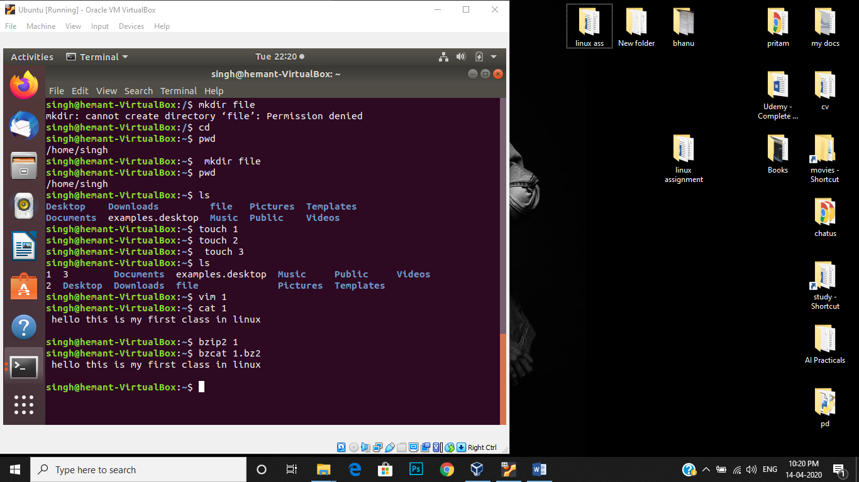

**Q2. What should be the argument to be given to unzip that file**

Ans. Unzip filename –d pathname

“-d” argument used to be given to unzip the file

**Q3. How to change the shell of user to “/bin/sh” at the time of**

**adding the user.**

Ans.Run the following command:

